IP CABLING TRANSMISSION – POE Switch
ITEM NO.: IP05H 5 Port POE Switch

IP05H PoE switch is specifically designed to meet IEEE 802.3af standards with support up to Gigabit speed and powering network devices. With PoE installation of network devices such as IP surveillance cameras, wireless access points, IP phones, and other PoE enabled devices in hard-to-reach, outdoor, and remote areas is simplified.
The 4-port 10/100
Features:
- 4-Port 10/100/1000Mbps with embedded PoE Injector.
- 1-Port 10/100/1000Mbps for connecting to LAN.
- Auto-sensing for detecting PoE or non-PoE devices.
- Compatible IEEE 802.3af PoE standard.
- 2 units install at TPN002 rack mounting become 8 ports Switch.
- Internal power supply.
- Option Model: TRN002 1U 19” Rack Mounting Panel

Installation View:

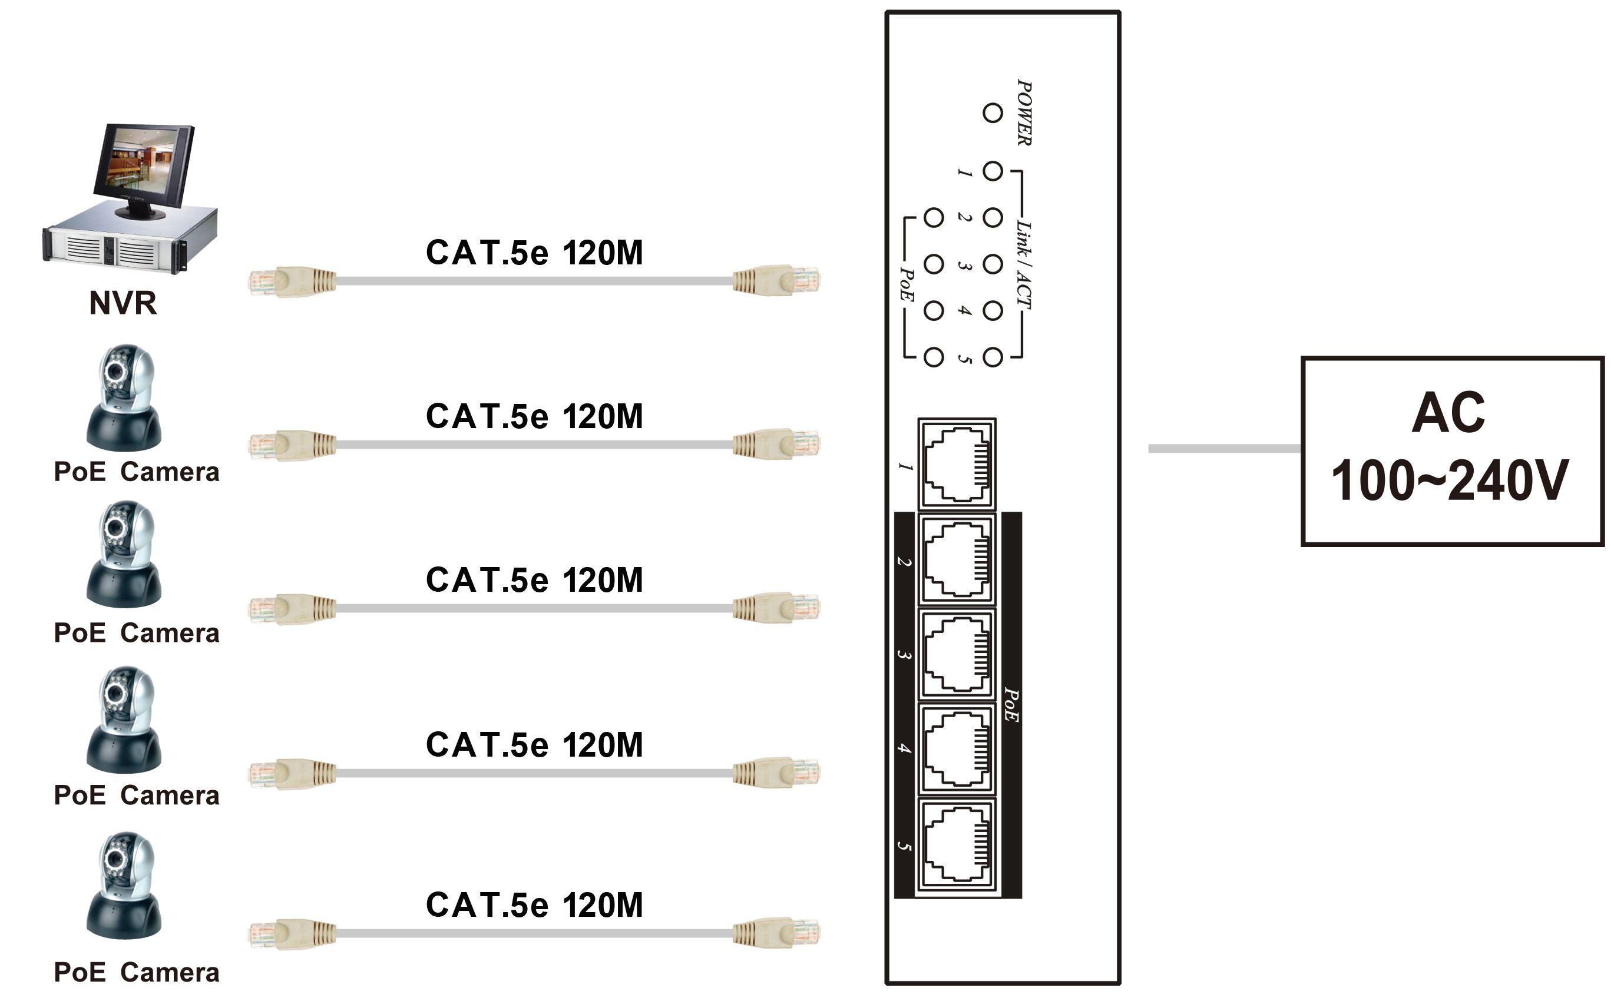

- Option Model: TRN002 1U 19” Rack Mounting Panel
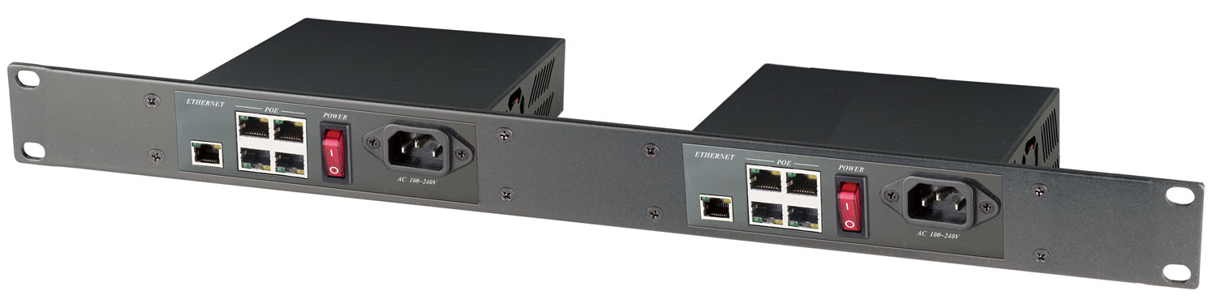

Panel View:

IP05H
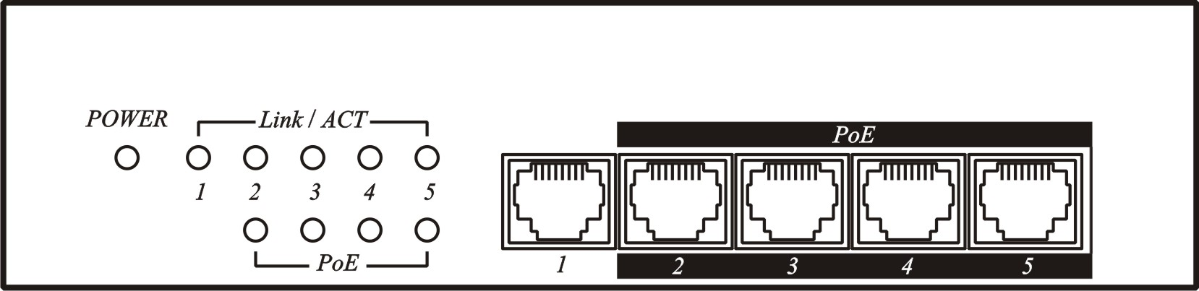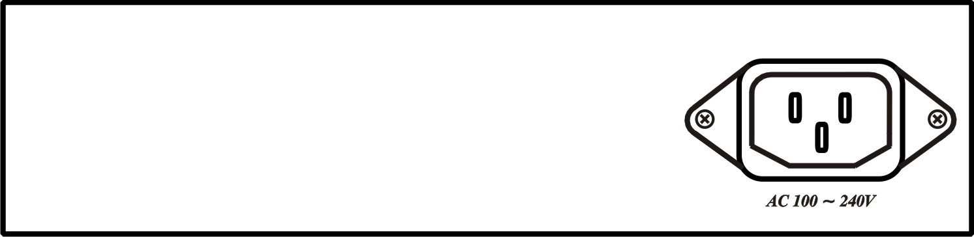

LED Indication:

LED (Green) | ON | Power on
LED (Green) | OFF | Power off
Link/ACT (Yellow) | ON | 10/100/1000 Mbps link
Link/ACT (Yellow) | OFF | 10/100/1000 Mbps unlink
Link/ACT (Yellow) | FLASH | Activity
PoE (Green) | ON | PSE sending power
PoE (Green) | OFF | PSE non power

Specification:

ITEM NO. | IP05H
Input/Output Connector | RJ-45 x 5
Data Link | Pins 1, 2 / 3, 6 / 4, 5 / 7, 8
Power LinK | Pins 1, 2 / 3, 6 (End-Span)
LED Indicator | Power(Green), 10/100/1000/Act(Yellow), PoE(Green)
PoE Port Power | IEEE 802.3af Standard (1-Port 15.4 Watts/300mA)
Power Supply | DC 48V 65W 1.36A
Power Consumption | Non-load 1.06W (22mA)，4port 2.4W (50mA)@10/100Mbps，4port 4.3W (89mA)@1000Mbps
Temperature | Operation：0 to 55°C, Storage：-20 to 85°C, Humidity：Up to 95%
Dimensions | 167 x 96 x 40 (mm)
Weight | 620 (g)

Rev.A

FORESIGHT CCTV INC.
5863 Leslie Street, Unit#713, North York, Ontario, Canada, M2H 1J8
http://www.foresight-cctv.com | 1-888-GO2-CCTV

